**Phase one sections:** Homepage, About, Products, News, Contact

**Phase two sections:** Advertise, Careers

**Phase one**

**I) Homepage**

**Logo masthead** – *In production. Insert April 4 FPO logo on white background for time being.*

**Header tabs** – Home, About, Products, News, Contact (add Advertise and Careers in phase 2)

Add search bar in top-right corner of header tab (like FEN Learning)

**Top banner** – *In production. Placeholder: FEN Learning art. Specs:* *1680x1059, RGB.*

**Tagline for Top banner** – Boundless Worlds. Timeless Lessons.

**II)** About **Us**

**Copy for this section –**

Storytellers. Entertainers. Educators. Creators. Put them all together, and you’ve got StoryArc Media.

**{Truncate after this graph} {MORE} button**

At StoryArc Media, we create fun, engaging, interactive experiences that light up kids’ faces and brains. Every day and all around the world, kids enjoy our online games, mobile apps, books, and more, including Poptropica, Funbrain, and Galactic Hot Dogs.

Parents and educators think we’re pretty cool, too, because while StoryArc Media creations are oodles of fun, they also also educate and reward players. And our online games and apps for kids under 13 carry the KidSAFE seal, so adults can be assured that children are exploring in a safe environment.

**Side banner** – *In production. In production. Placeholder: FEN Learning art. Specs: 510x605, RGB.*

Meet **Our Team**

**Copy for this section –**

StoryArc Media’s super awesome team of game developers shares the same passion about our creations that we see among our fans. The enthusiastic feedback we receive from kids and parents every day humbles us, inspires us, and keeps StoryArc Media at our creative best!

Say hello to StoryArc Media’s team of game designers, artists, programmers, product managers, marketers, and more:

**Team headshots, titles and bios –** *being compiled. In the meantime, please display the following three names, titles, and headshots side by side in a row.*

**Jeff Kinney** **Jen MacLean**  **Jeff Faulconer**

Chief Creative Officer President, Kids & Games VP, Product Development

  

*We will have updated team headshots by April 12th. Team photos are being taken April 11th.*

*If possible, we would like the photos to be cropped into circles and displayed about each person’s name, title, and truncated bio – the later expanding when visitors click, “Read More.”*

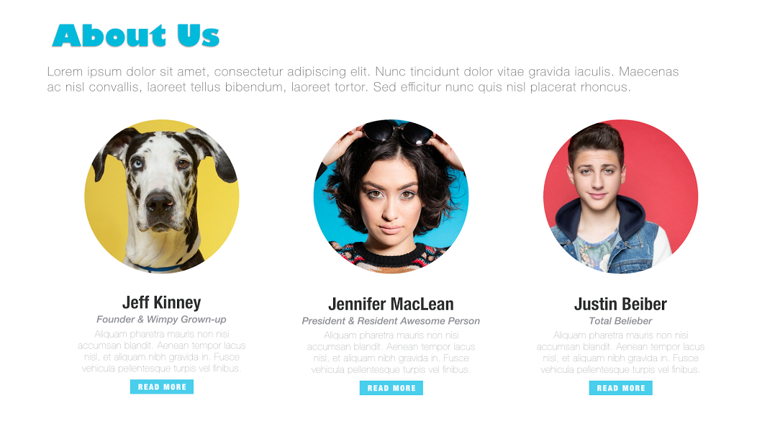

**III)** Our **Creations**

**Copy for this section –** Curious, wide-eyed Poptropicans. Piling-up pigs and parachuting penguins. And of course, hot-dog slinging space adventurers. StoryArc Media creations are all unique yet united by original, engaging, and giggle-inducing stories! **{MORE} button**

**Poptropica**

Explore. Create. Collaborate.

Created by famed author Jeff Kinney, Poptropica is an episodic virtual world in which kids explore a chain of story-based islands, travel back in time, battle monsters, solve mysteries, and complete quests for free in a kidSAFE-certified environment. Poptropica also has its own New York Times best-selling graphic novel,[*Mystery of the Map*](http://www.poptropica.com/books/mysteryofthemap/vol1), with the eagerly-awaited follow-up book coming in August 2016.

For links, please invert what we did for Poptropica Apps (see screenshot below), so the “Play Online!” button sits on top of “Get the App!” and the three hyperlinked app store badges. The app store badges should be in the following order: App Store, Google Play, Amazon.



Web link: www.poptropica.com

App Store: https://itunes.apple.com/us/app/poptropica/id818709874?mt=8

Google Play: https://play.google.com/store/apps/details?id=air.com.pearsoned.poptropica&hl=en

Amazon: http://www.amazon.com/Family-Education-Network-Poptropica/dp/B013D6V64G

**Funbrain**

*Growing kids’ brains through fun games*

Since 1997, kids, teachers, librarians, and parents have enthusiastically turned to Funbrain for its free educational games, online books, and comics. Created for kids ages preschool through grade 8, Funbrain offers more than 100 engaging interactive games that develop skills in math, reading, and literacy in a safe online environment.

Please use the same “Play Online!” button.



Web link: http://www.funbrain.com

**Galactic Hot Dogs**

*Friendship, courage, and crazy space adventures*  
The *Galactic Hot Dogs* books invite kids to go on a wild ride with Cosmoe, Princess Dagger, and Humphree as they embark on a series of intergalactic adventures. Space pirate zombies, mutant worms, the Ultimate Evil — and soon, a deceptively dangerous cosmic circus — are all among the challenges our humorous heroes face as they travel through the galaxy on their ship, the Neon Wiener!

**Call to action:** Get the books!

**Link:** http://www.simonandschuster.com/series/Galactic-Hot-Dogs

{Trying to track down the below button from our GHD art for use on the site}



**IV) News, Press, and other good stuff**

**Copy for this section –** Cool stats? Check. News and press? You got it. Some awesome awards? It’s all here. **{MORE} button**

**Fun facts –** *Will provide unique visual elements and final numbers for all six facts. For the time being, please use small placeholder icons and lay them and the associated text out three in a row over two rows. Alternatively, they could be displayed 2 side by side along 3 rows.*

|  |  |  |
| --- | --- | --- |
| **Total # of registered players:** 5.3M | **Global presence:** 200+ countries | **Total # of avatars created:** 10.2M |
| **Total # of Realms built:** 1.3M | **Total # of medallions earned:** 9.4M | **Total # of problems solved:** Too many to count. |

**Newsletter** *– Can MailChimp be integrated in the manner outlined in the PDF? If so, will provide a graphical/hero element for this element to be placed between IV) and V). Text is as follows.*

**HEADLINE:** Get the scoop on StoryArc Media!

**BODY:** Subscribe to our newsletter for the latest on our products, people, and more! No spam, we promise.

*Email header and body copy to follow.*

VII) **Talk** to Us

*Will provide an office photo by April 12.*

**COPY:** Interested in advertising opportunities? Think you might want to join our amazing team?

Need help of some sort? Here’s how to get in touch with StoryArc Media. **{MORE} button**

Will update the below contact info with actual details by April 6.

**Advertising**

advertise@fen.com

**Support**

Poptropica: <http://www.poptropica.com/contact/contact-parents.html>

**Careers**

Check out our LinkedIn page and see what positions we’re hiring or email us at [careers@fen.com](mailto:careers@fen.com).

{LinkedIn URL: https://www.linkedin.com/company/family-education-network}

**Media**

info@fen.com

*Include social media icons that link to StoryArc Facebook, Twitter, and LinkedIn.*

Facebook

https://www.facebook.com/StoryArcMedia

Twitter

https://twitter.com/storyarcs

LinkedIn

Same as above